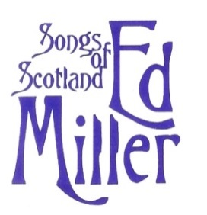
Ed Miller’s Folksong Tours of Scotland 2024
Application form
Please reserve a place/_____places for Tour No.1 May 26 – June 5
Please reserve a place/_____places for Tour No.2 June 16-26
I enclose a $500 per person deposit, which is not refundable should I cancel after 1 Jan 2024 unless a replacement can be found from the waiting list.

Name 1__________________________________Date of Birth___/___/____
Name 2__________________________________Date of Birth___/___/____
Address_______________________________________________
________________________________________________
_________________________________________________
Telephone number : ( )_____-_____
E-Mail address :______________________________
Passport No._________________________________
Covid vaccination – I confirm that I agree to taking a Covid test before the start of the tour if necessary

Please check one of the following :
____We will share a room
____I would like to be allocated a roommate
____I would like to reserve a single room ($750 additional fee)

Are there any allergies, phobias, medical conditions or dietary needs we should be aware of? ____________________________________________________

I enclose a check/money order for $________for_________person/s
or
*Please charge $_______to my credit card. Name on card_________________
Visa/Mastercard No______________________Exp. Date_______ Sec.No____
*(please be aware that a 4% processing fee will be added if paying by credit card)

Please mail payment to : Ed Miller Folksong Tours, 2411 W 8th St, Austin TX 78703

